**EP8280L 2D FIXED SCANNER**

# **INTEGRATION GUIDE**

# Table of Contents

INTEGRATION GUIDE 1

Table of Contents 2

Chapter 1 About EP8280L 5

1.1 Introduction 5

1.2 Illumination 6

1.3 Good Read LED 6

1.4 Symbologies Chart 7

Chapter 2 Installation 9

2.1 Introduction 9

2.2 General Requirements 9

2.3 EP8280L Dimension（：mm） 11

2.4 External Design 12

2.5 Optically relevant 14

2.5.2 Window material and color 14

2.6 Coatings and Scratch Resistance 15

2.6.1 Anti-reflection coatings: 15

2.6.2 Polysiloxane coatings: 15

2.7 Window Size 16

2.8 Ambient Light 16

2.9 Eye Safety 16

Chapter 3 Electrical Specifications 16

3.1 Power Supply 17

3.2 Ripple Noise 17

3.3 DC Characteristics 17

3.3.1 Operating Voltage / Current 17

3.3.2 I/O Voltage 18

3.4 Timing Sequence 18

Chapter 4 Interfaces 20

4.1 Interface Pinouts 20

4.2 EP8280L Interfaces Pinouts 21

4.2.1 12-pin FPC Connector 21

4.2.2 8-PIN Box Connector 22

4.2.3 12-PIN FPC Connector 23

4.2.4 8-PIN RS232 Box Connector 24

4.2.4 12-PIN FPC 25

4.2.5 8-PIN USB box cable 26

4.2.6 8-PIN RS-232 Box Cable 27

Revision

|  |  |  |
| --- | --- | --- |
| **Versin** | **Description** | **Date** |
| V1.0 | Initial Release | 2023-5-17 |

# Chapter 1 About EP8280L

## 1.1 Introduction

The EP8280L is an area image engine for barcode reading. It includes 4 illumination LEDs, 2 Good Read LEDs, one 12-pin FPC connector and two 8-pin box connectors.

The EP8280L contains：

* 1 Cmos sensor
* 4 Illumination LED
* 2 Indicator LED

## 1.2 Illumination

The EP8280L has 4 LEDs for supplementary lighting, making it possible to scan

Barcodes even in complete darkness. The illumination can be turned On or Off.

## 1.3 Good Read LED

There are 2 LEDs for Good Read notification. During scanning, and once the EP8280L decodes, the green LED will be on. The Good Read LED can be turn on or turn off though scanning program barcode and the time duration of notification can be programmed though serial command or program code barcode. For more detail, please refer to user program manual.

## **1.4 Symbologies Chart**

|  |  |  |  |
| --- | --- | --- | --- |
|  | **Type** | **Support** | **On** |
| 1D | Codabar | √ | × |
| Code 11 | √ | × |
| Code 128 | √ | √ |
| Code 32 | √ | × |
| Code 39 | √ | √ |
| Code 93 | √ | √ |
| EAN-8 | √ | √ |
| EAN-13 | √ | √ |
| ISBN | √ | √ |
| ISSN | √ | √ |
| GS1 DataBar | √ | × |
| GS1 DataBar Limited | √ | × |
| GS1 DataBar Expanded | √ | × |
| GS1 DataBar Stacked | √ | × |
| Interleaved 2 of 5 | √ | × |
| Industrial 2 of 5 | √ | × |
| Matrix 2 of 5 | √ | × |
| MSI Plessey | √ | × |
| UPC-A | √ | √ |
| UPC-E0 | √ | √ |
| UPC-E1 | √ | × |

Continued

|  |  |  |  |
| --- | --- | --- | --- |
| 2D | Aztec Code | √ | × |
| Data Matrix Code | √ | × |
| PDF417 | √ | × |
| Micro PDF417 | √ | × |
| QR Code | √ | √ |
| Micro QR Code | √ | √ |

# Chapter 2 Installation

## 2.1 Introduction

This chapter provides information about installing the EP8280L, including physical and electrical information, considerations, and recommended EP8280L window properties.

△! Warning: Do not touch the imaging lens when installing the scanner and avoid the thumbprint remaining on the lens.

△! Warning: Be careful not to touch the lighting LED during handling. Improper handling can damage LED and lenses.

#### 

#### **2.2 General Requirements**

#### **ESD**

The EP8280L has been designed to protect against static electricity, but due to module volume limitations, the static protection of some signals with the client interface cannot be handled in place, such as the use of the scene on the static protection level requirements are higher, the customer needs to consider the static protection design on the relevant interface. The module uses anti-static packaging, but in the process of unsealing and use still need to pay attention to anti-static measures, such as the use of ground wristbands and other measures.

#### **Dust-proof and anti-fouling**

The EP8280L must be sufficiently sealed during storage and use to prevent dust, particles or other contaminants from gathering and sticking to components such as lenses, circuit boards, LEDs, etc. Dust particles or contaminants can degrade engine performance and even affect engine use.

#### **Environment**

The normal use of the EP8280L is subject to the environmental requirements in the table below. Table 2-1:

|  |  |
| --- | --- |
| Operating Temperature | -40℃ to 70℃ |
| Storage Temperature | -40℃ to 75℃ |
| Humidity | 5% ~95% （Non-Condesing） |

#### **Heat dissipation**

Embedding the EP8280L in any product requires heat dissipation design. There are several high-power devices (e.g. CPU, CIS, LEDs, DC/DC, etc.) on the EP8280L, reading the scanner that emit a lot of heat when working continuously. The local temperature rise of the EP8280L may increase when working continuously at full speed. When the ambient temperature is high, the image noise of the image sensor will be increased, the image quality will be reduced, and the reading performance will be affected.

When integrating applications, the power consumption and heat of the EP8280L can be reduced as follows:

* Avoid using LEDs for long periods of time in a continuous mode of operation.
* Designed to reserve space for the EP8280L to form natural or forced currents.
* Avoid tightly wrapping the EP8280L with insulation such as rubber.

#### **Optical**

Do not expose the external optics of the EP8280L to any external forces.

Do not pinch an external optical component of the engine by hand, which may cause too much stress at the mechanical connector, which may cause its fixing components to fail, such as a broken device or a broken cable.

## 2.3 EP8280L Dimension（：mm）

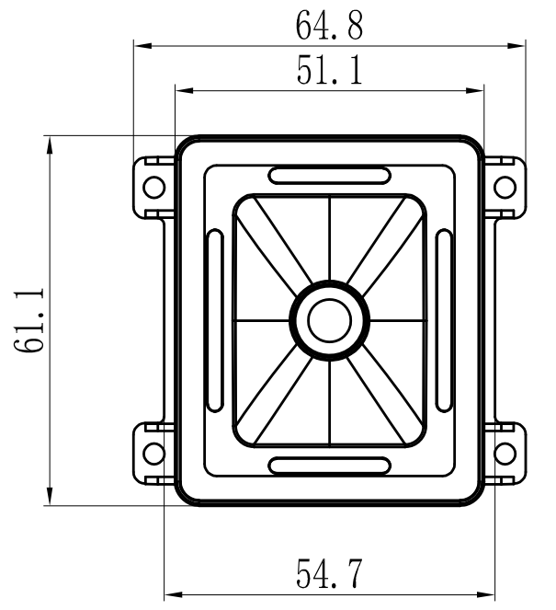

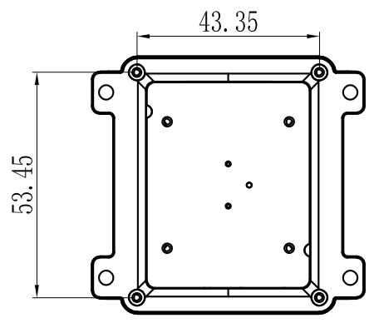

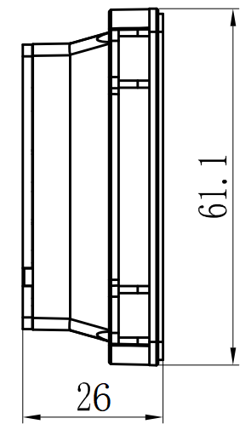 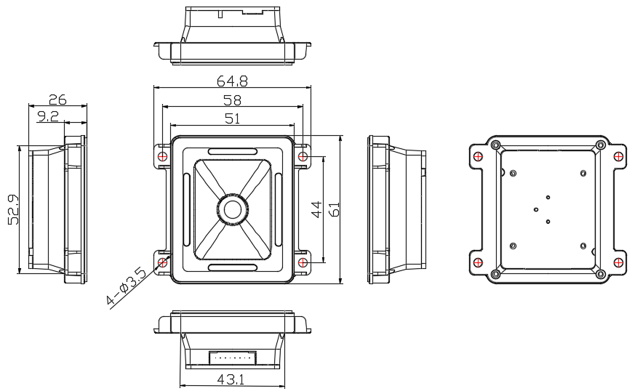

## 2.4 External Design

Note: Optical analysis of the housing design ensures optimum scanning or imaging performance.

Design the engine housing so that the aiming and lighting systems do not reflect internally. Reflections from windows or shells can cause problems. For special window tilt angles, these reflections bounce from the top or bottom of the housing and reach the engine. Do not place bright objects around the engine to prevent the tilted window from being reflected into the engine's field of view and appearing in the captured image. Consider using a black matte material inside the bezel or housing.

## 2.5 Optically relevant

2.5.1 Window positioning

The window is a transparent medium mounted in front of the EP8280L scanner that separates the inside and outside of the product and preserves the light path for the scanner to read the barcode. The window should be placed so that the illumination beam and aim beam are ejaculed as far as possible and to prevent reflections from entering the engine. If the lighting beam is reflected into the engine, the engine's readability performance is reduced.

The window should be installed as close as possible to the front of the EP8280L, and a-0mm.。

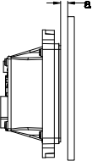

Figure 2-4

### 2.5.2 Window material and color

Window material must be clear. Use only cell-cast plastics or optical glass. PMMA, ADC and chemically tempered glass are recommended. Window material selected for the engine should meet or exceed the specifications specified in Table 2-2.

• PMMA (Cell-cast acrylic): When fabricated by cell-casting, has very good optical quality and low initial cost, but surface must be protected from the environment due to its susceptibility to attack by chemcials, mechanical stresses, and UV light. Reasonably good impact resistance. This material can be laser-cut into odd shapes and ultrasonically welded. • ADC (CR-39): A thermal-setting plastic produced by the cell-casting process. Excellent chemical and environmental resistance. Quite good surface hardness, and therefore does not have to be hard-coated. Reasonably good impact resistance. This material cannot be ultrasonically welded. • Chemically tempered glass: Glass is a hard material which provides excellent scratch and abrasion resistance. But unannealed glass is brittle. Increased flexibility strength with minimal optical distortion requires chemical tempering. 9 Glass is hard to be cut into odd shapes and cannot be ultrasonically welded.

Sheet 2-2：

|  |  |
| --- | --- |
| Specification | Description |
| Thickness | 0.8-2.0mm |
| Wavefront Distortion | PV maximum: 0.2λ RMS maximum: 0.04λ |
| Clear Aperture | 1.0mm to edges |
| Surface Quality | 60-20 scratch/dig |

Pay extra attention to the wavefront distortion when using plastic materials. Colored windows are not recommended if the engine is used to scan barcodes on moving objects.

## 

## 2.6 Coatings and Scratch Resistance

### 2.6.1 Anti-reflection coatings:

Anti-reflection (AR) coatings can be applied to window surfaces to reduce reflected light from the window back into the engine. But they are expensive and have poor abrasion/scratch resistance.

### 2.6.2 Polysiloxane coatings:

Polynesian coatings can be applied to plastic surfaces to increase the surfaces’ abrasion and scratch resistance.

Scratch on the window can greatly reduce the performance of the EM20-80. It is suggested to use abrasion resistant window material or coating.

## 2.7 Window Size

The window must not block the field of view and should be sized to accommodate the aiming and illumination envelopes shown below.

Horizontal:

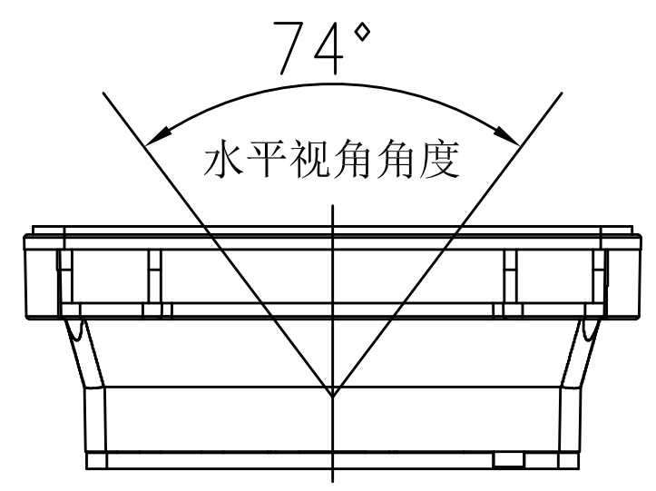

Vertical:

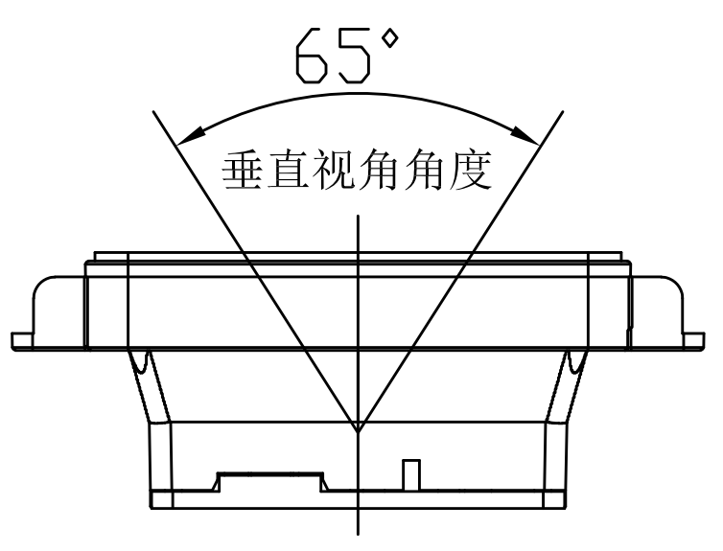

## 2.8 Ambient Light

The EP8280L shows better performance with ambient light. However, high-frequency pulsed light can result in performance degradation. 。

## 2.9 Eye Safety

The EP8200L has no lasers. It uses LEDs to produce illumination beam. The LEDs are bright, but testing has been done to demonstrate that the engine is safe for its intended application under normal usage conditions. However, the user should avoid looking into the beam.

# Chapter 3 Electrical Specifications

## 3.1 Power Supply

Do not power up the EP8280L until it is properly connected. Be sure the power is cut off before connecting a cable to or disconnecting a cable from the host interface connector. Hot-plugging could damage the engine. Make sure that the FFC cable is horizontally inserted into the connector when connecting the engine’s 12-pin connector to the host. Improper cable installation or unstable power supply or sharp voltage drops or unreasonably short interval between power-ons may lead to unstable performance of the engine. Do not resupply the power immediately after cutting it off.

## 3.2 Ripple Noise

To ensure the image quality and engine performance, a power supply with low ripple noise is needed.

## 3.3 DC Characteristics

### 3.3.1 Operating Voltage / Current

**Sheet 3-1**（T=23℃）

|  |  |  |  |  |  |
| --- | --- | --- | --- | --- | --- |
| **Parameter** | **Descriptin** | **Minmum** | **Typical** | **Maximm** | **Uit** |
| Operating Voltage | VIN (12-pin FPC Connector) | 4.8 | 5 | 16 | V |
| VIN (4-pin Box Connector) | 4.8 | 5 | 16 | V |
| Current (@5.0V) | Operating Current | 182 | 120 | 150 | mA |
| Idle Current | 55 | 65 | 66 | mA |

### 3.3.2 I/O Voltage

Sheet 3-2

VDD=3.3V, VSS=0V, T=23°C

|  |  |  |  |
| --- | --- | --- | --- |
| **Parameter** | **Min.** | **Max.** | **Unit** |
| VIL | -0.3 | 0.7 | V |
| VIH | 2.4 | 3.6 | V |
| VOL | VSS | 0.45 | V |
| VOH | 1.35 | VDD | V |

## 3.4 Timing Sequence

Power Up and Power Down Timing Sequence

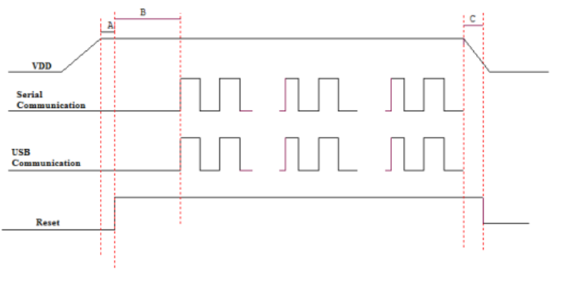

1. In the diagram above, it takes A+B (about 940ms) for the engine to power up: A is reset time (about 280ms), B is time needed to start the engine (including bootloader execution, kernel boot and decoding chip initialization). The engine is ready to receive commands via its serial/USB port after the power-up sequence completes. 2. C is the time it takes to power down the engine (during power-down, all voltages in the engine ramp down, with all communication stopped and all signals at a low level). To ensure that all voltages are fully down and signals on the interfaces at a low level, the minimum interval between removing and resupplying the power must exceed 700ms.

**Chapter 4 Interfaces**

## 4.1 Interface Pinouts

The physical interface of the EP8280LL consists of a 12-pin FPC connector and two 8-pin box connectors:。

* + 12-pin FPC connector can be used as TTL-232 interface or USB interface.

One 8-pin box connector can be used as standard USB interface and the other as RS-232 interface

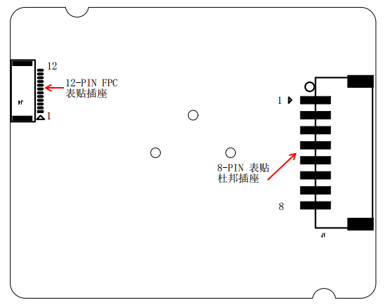

#### Figure 4-1

## 4.2 EP8280L Interfaces Pinouts

### 4.2.1 12-pin FPC Connector

|  |  |  |  |  |
| --- | --- | --- | --- | --- |
| **PIN#** | **Signal Name** | **I/O** | **Functin** | **Remark** |
| 1 | nTRIG | I | Trigger Signal Output |  |
| 2 | nRESET | I | Reset |  |
| 3 | LED | O | LED Output |  |
| 4 | Buz | O | Beeper Output |  |
| 5 | PIN 8 | - | Null |  |
| 6 | USB_DP | I/O | USB D+ Signal |  |
| 7 | USB_DN | I/O | USB D- Signal Power Supply Ground |  |
| 8 | TXD | O | TTL signal transmit |  |
| 9 | RXD | I | TTL signal receive |  |
| 10 | GND | - | RS232 receive data/TTL232 receive data/ RS485 data B |  |
| 11 | VIN | - | Power Supply 5~16V |  |
| 12 | NC | - | NULL |  |

|  |  |  |  |
| --- | --- | --- | --- |
| PIN# | Signal | I/O | Function |
| 1 | POW_IN |  | +5V~16V Power Supply Input |
| 2 | GND |  | Power Supply Ground |
| 3 | RS232_RX | I/O | RS232-Receive |
| 4 | RS232_TX | I/O | RS232-Transmit |
| 5 | USB_DP | I/O | USB_D+ Signal |
| 6 | USB_DN | I/O | USB_D- Signal |
| 7 | LED | O | LED Signal output |
| 8 | nTRIG | I | Trigger Signal output |

## 4.2.2 8-PIN Box Connector

Connector/Cable Specifications (Unit: mm)

12-pin FPC connector and two 8-pin box connectors.

### 4.2.3 12-PIN FPC Connector

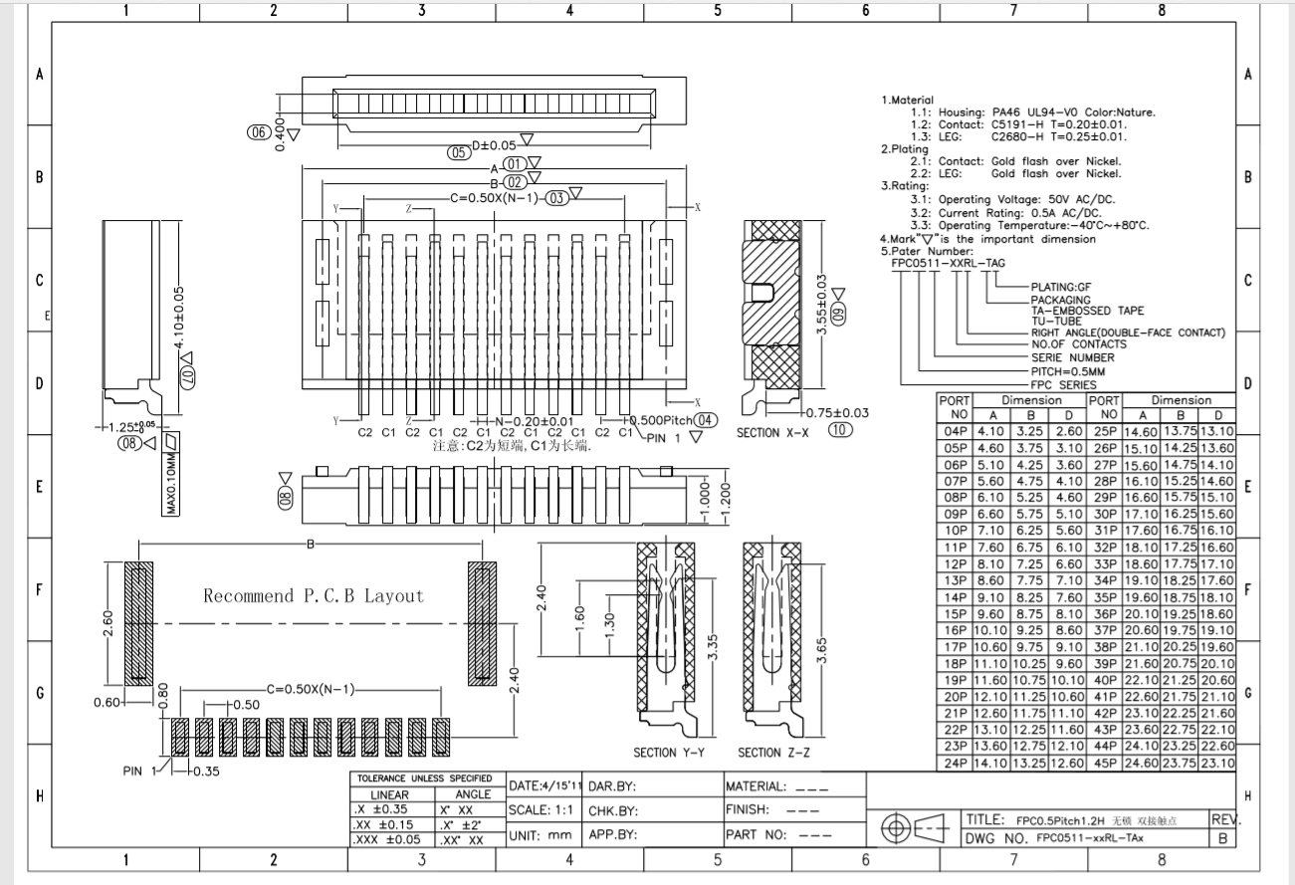

#### Figure 4-2

### 4.2.4 8-PIN RS232 Box Connector

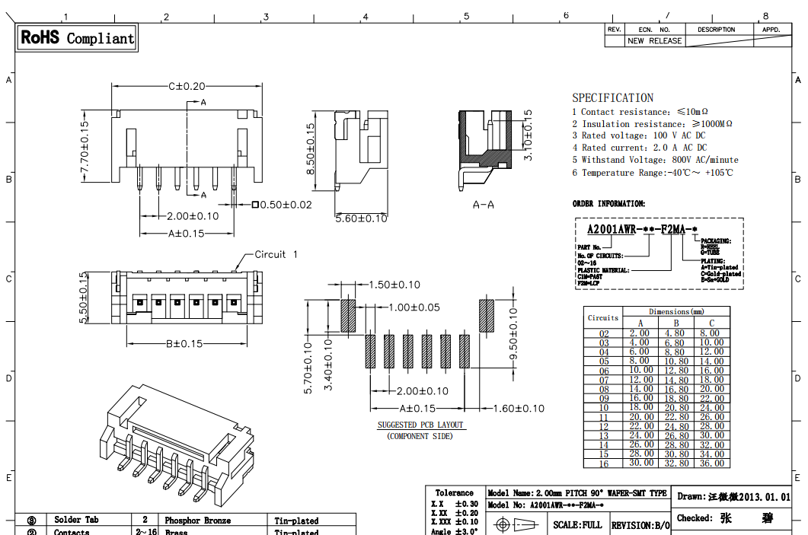

Figure 4-3

### 4.2.4 12-PIN FPC

A 12-pin cable can be used to connect the engine’s 12-pin FPC connector to a host device.

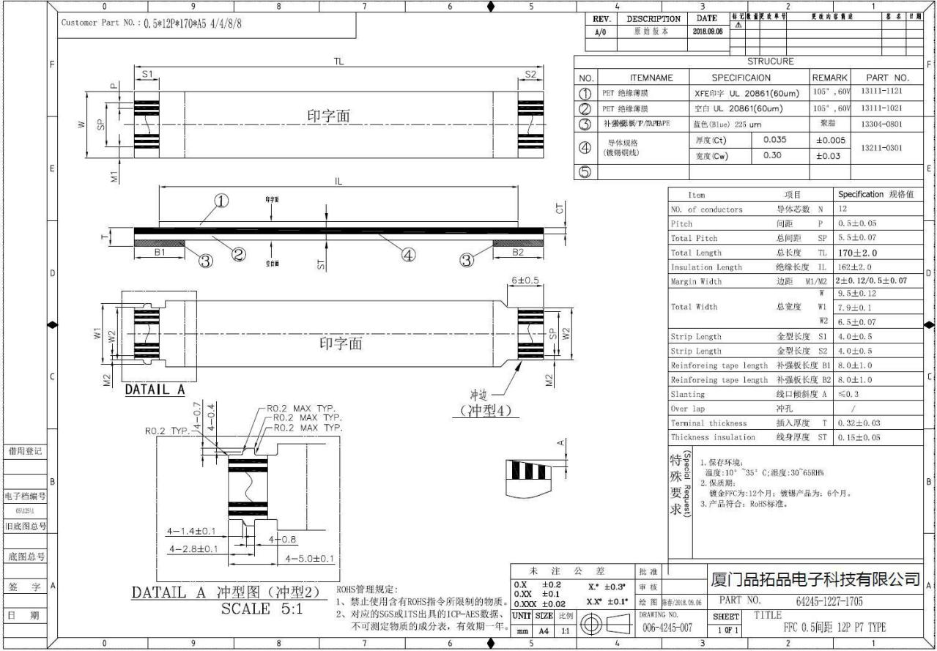

Figure 4-4

### 4.2.5 8-PIN USB box cable

A 8-pin female cable can be used to connect the engine’s 8-pin box connector (male) to a host device

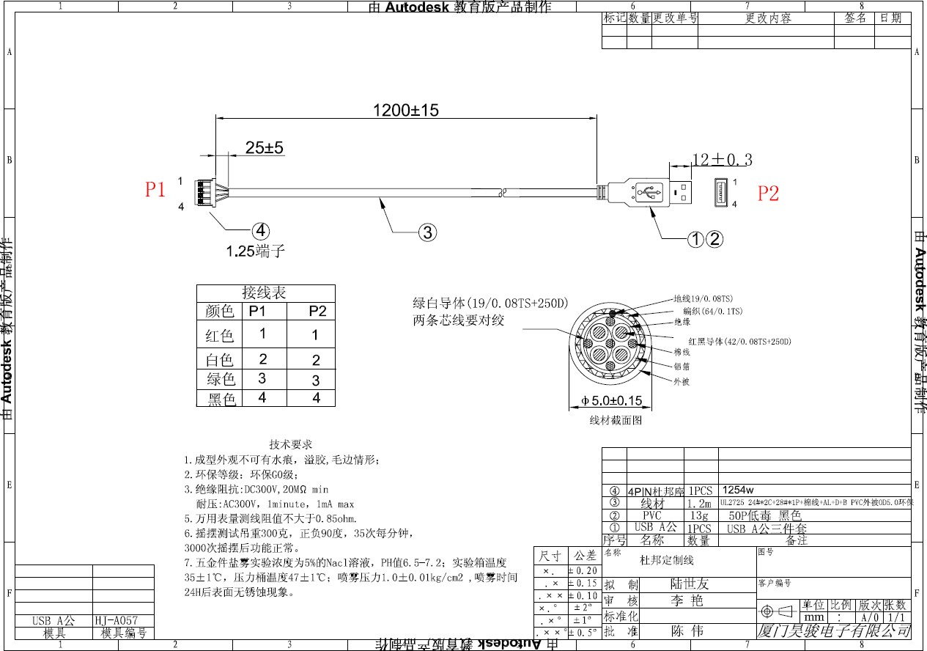

Figure 4-5

### 4.2.6 8-PIN RS-232 Box Cable

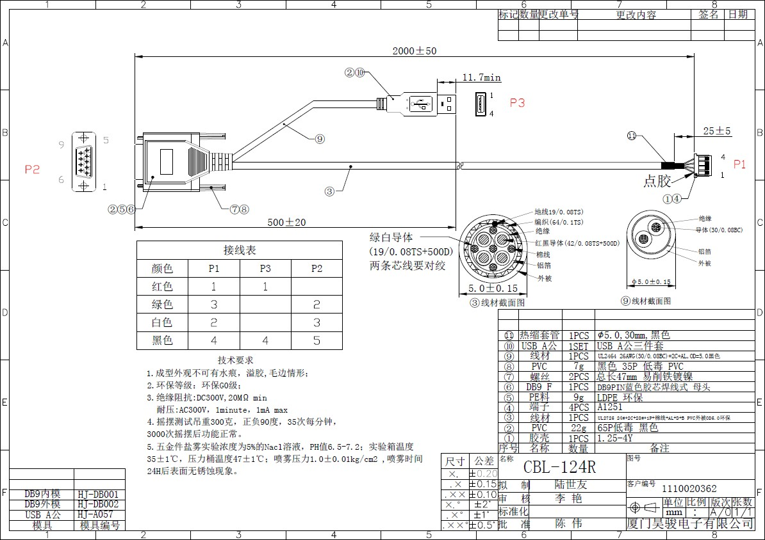

Figure 4-6